**Brain Fizz Play Test**

Joseph O’Keeffe – C00258019

**Intro**

After getting people to play test our game here are the results. I got them to play the game and didn’t tell them anything about it. I then asked them what they thought of it, wrote down notes that I observed and things they said, and gave them a questionnaire.

**General Feedback**

Overall, the people who we got to play our game thought it was good but had quite a bit of stuff missing. The notes I gathered were:

* In the tutorial, right clicking on the walls to move to the next zone wasn’t clear
* In the tutorial, the drop item button was not clear
* You could attack and move while in dialogue
* Dialogue wasn’t very clear
* NPCs would be flying in the air
* No way of knowing what to do
* Some items couldn’t be picked up
* Lots of walking around but not much to do

**Questionnaire Results**

Here are the results collected from the questionnaire after the play test



They found the game okay, although there were quite a few bugs

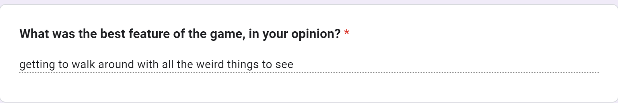

All of those fun weird things that were in the game were added by me so that is a good thing to hear

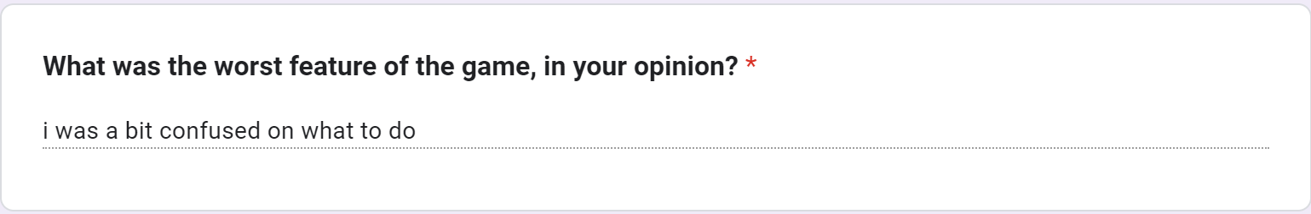

Yeah the direction of the game was not very clear at all and a lot of improvements could be made to it

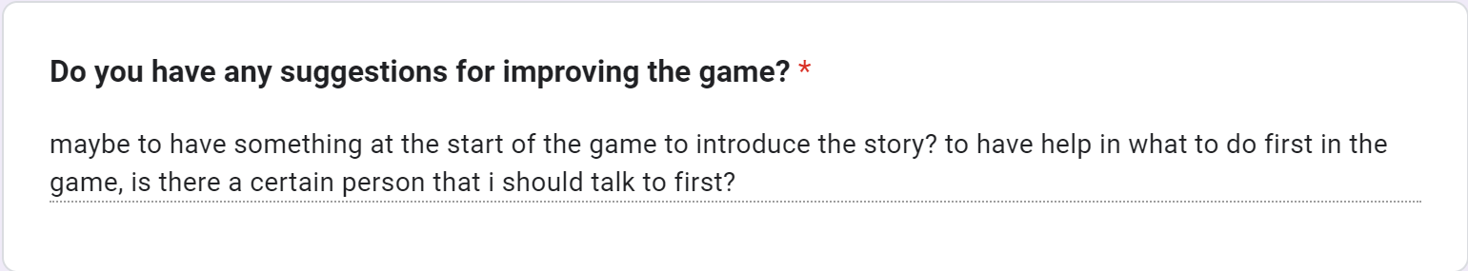

When they first started the game they did look very confused so this would be something that we would need to clear up





There was a button to show the controls in the game but they must have forgotten about it

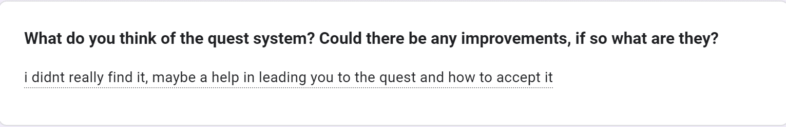

When they miss the first important dialogue option you don’t get any quests so that is reasonable

This was mainly due to the confusion of the NPCs and not knowing what dialogue options to pick

**Changes I made from them**

I changed the NPCs around to make it easier to understand what is going on. I also changed the dialogue so the story is clearer.

The character at the start introduces you to the story more now and is clearly laid out so you won’t miss him when you start

There will be more enemies in the game which makes combat a lot more necessary.

I have changed the dialogue so it will hopefully make the characters more interesting.

I can add things into the game that makes it necessary to use the other movements such as places to roll under, crouch under etc.

I added more creatures with health so you can attack and kill things now

Finding a quest is now easier as the dialogue has been made clearer and the options to choose are more obvious

NPCs will no longer fly because they were given gravity

Dropping items is clearer now with the tutorial telling you how to

All important items can now be picked up along with much more

You can no longer move and attack during dialogue

**Conclusion**

The game still needs lots of work but after that one playtest I learned a lot. By observing how someone not familiar to the game played it I could make some very good changes to it. In the future I might get other people to play test it and see how different they play the game compared to the first play test